1. 測試內容：

測試 Switch CLI中Meter table之Meter flags “Counters”項目是否正確統計與跟meter相關之flow rule(s)數量。

1. 測試環境架構：

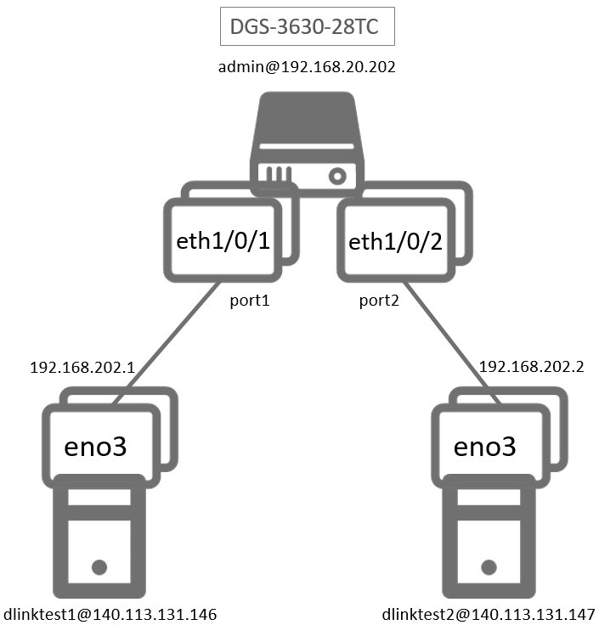

1. 測試環境組態：

* SDN controller: ONOS 1.15.0
* Switch: DGS-3630
* Hosts:
  + ubuntu 16.04.5 LTS
  + dlinktest1(實體機)
    - IP: 192.168.202.1
    - MAC: d0:94:66:5d:5e:08/64
    - Port: 1
  + dlinktest2(實體機)
    - IP: 192.168.202.2
    - MAC: d0:94:66:5c:45:20/64
    - Port: 2
* Apps:

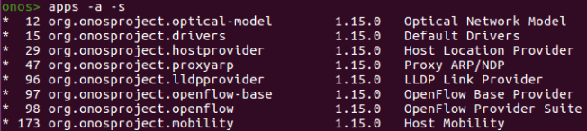

1. 使用之JSON文件：
   * Flow Rule: (附檔：kbpsFlow1.json)

|  |
| --- |
| {  "flows": [  {  "priority": 98,  "timeout": 0,  "isPermanent": true,  "deviceId": "of:000078321bdf4000",  "treatment": {  "instructions": [  {  "type": "OUTPUT",  "port": "1"  }  ]  },  "selector": {  "criteria": [  {  "type": "IN_PORT",  "port": "2"  }  ]  }  },  {  "priority": 99,  "timeout": 0,  "isPermanent": true,  "deviceId": "of:000078321bdf4000",  "treatment": {  "instructions": [  {  "type": "METER",  "meterId": 1  },  {  "type": "OUTPUT",  "port": "2"  }  ]  },  "selector": {  "criteria": [  {  "type": "IN_PORT",  "port": "1"  }  ]  }  }    ]  } |

* + Flow Rule: (附檔：kbpsFlow2.json)

|  |
| --- |
| {  "flows": [  {  "priority": 100,  "timeout": 0,  "isPermanent": true,  "deviceId": "of:000078321bdf4000",  "treatment": {  "instructions": [  {  "type": "OUTPUT",  "port": "1"  }  ]  },  "selector": {  "criteria": [  {  "type": "IN_PORT",  "port": "3"  }  ]  }  },  {  "priority": 101,  "timeout": 0,  "isPermanent": true,  "deviceId": "of:000078321bdf4000",  "treatment": {  "instructions": [  {  "type": "METER",  "meterId": 1  },  {  "type": "OUTPUT",  "port": "1"  }  ]  },  "selector": {  "criteria": [  {  "type": "IN_PORT",  "port": "3"  }  ]  }  }    ]  } |

* + Meter Rule: (附檔：kbps.json)

|  |
| --- |
| {  "deviceId": "of:000078321bdf4000",  "id": 1,  "unit": "KB_PER_SEC",  "burst": true,  "bands": [  {  "type": "DROP",  "rate": "10240",  "burstSize": "10240"  }  ]  } |

1. 測試步驟：
2. ONOS GUI:

* Flow View

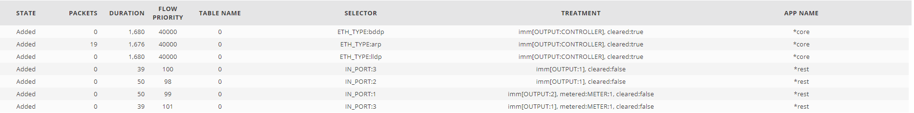

* Meter View



1. Switch CLI

* Reference Count = 2

|  |
| --- |
| Switch# show openflow meter-config |

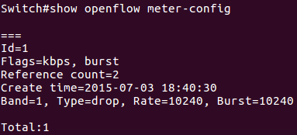

* Remove flow rules added by kbpsFlow1.json

|  |
| --- |
| $ curl -X DELETE --header 'Accept: application/json' 'http://192.168.20.62:8181/onos/v1/flows/of%3A000078321bdf4000/52072871492523858'  $ curl -X DELETE --header 'Accept: application/json' 'http://192.168.20.62:8181/onos/v1/flows/of%3A000078321bdf4000/52072874600139838' |

* Switch CLI show the correct reference count number after flow rules added by kbpsFlow1.json

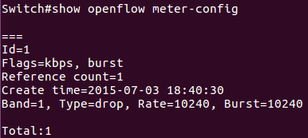

1. 測試結果：

Switch CLI中Meter table之Meter flags “Counters”項目可以正確統計與跟meter相關之flow rule(s)數量。